Supplementary material
Genome-wide analysis of Myo-inositol oxygenase gene family in tomato reveals their involvement in ascorbic acid accumulation

Shoaib Munir¹, Muhammad Ali Mumtaz¹, John Kojo Ahiakpa¹, Genzhong Liu¹, Weifang Chen¹, Guolin Zhou², Wei Zheng³, Zhibiao Ye^{1, 3}, and Yuyang Zhang ^{1, 3}*

¹ Key Laboratory of Horticultural Plant Biology, Ministry of Education, Huazhong Agricultural University, Wuhan 430070, China
² Wuhan Academy of Agricultural Sciences, Wuhan 430065, China
³ Huazhong Agricultural University Chuwei Institute of Advanced Seeds, Wuhan 430070, China
*Correspondence: Yuyang Zhang; Tel: +86 27 87283180; Fax: +86 27 87282010; Email: yyzhang@mail.hzau.edu.cn

Table S1. List of primer sequences.

Additional file 1. Primers used for real-time RT-PCR.
Gene | Full name | Accession No. | Forward primer (5'-3') | Reverse primer (5'-3')
SlMIOX4 | myo-inositol oxygenase gene | Solyc12g008650 | GAGAAAATGACTATTCTCATTGAGCAGCC | CCATGGATTCAATTACCACCTCAGC
GPI | glucose-6-phosphate isomerase | Solyc04g076090 | TGCTCTTCAAAAGCGTGTCC | CGGCAATAAGTGCTCTGTCA
PMI | phosphomannose isomerase | Solyc02g086090 | TACATTGTGGTGGAACGAGGA | ACCCCATTTGGCAAGAACAG
PMM | phosphomannomutase | Solyc05g048760 | TTTACCCTCCATTACATTGCTGA | TCTTCTTGACTACAGTTTCTCCCA
GMP | GDP-D-mannose pyrophosphorylase | Solyc03g096730 | AAACCTGAAATCGTGATGTGAGA | TGAAGAAGAGGAGAACTGGAAAC
GME1 | GDP-Mannose 3′,5′-epimerase1 | Solyc01g097340 | AATCCGACTTCCGTGAGCC | CTGAGTTGCGACCACGGAC
GME2 | GDP-Mannose 3′,5′-epimerase2 | Solyc04g077020 | CCATCACATTCCAGGACCAGA | CGTAATCCTCAACCCATCCTT
GGP1 | GDP-L-galactose-1-phosphate phosphorylase1 | Solyc06g073320 | GAAATCTGGTCTGTTCCTCTGTGA | TTCACACACCAACTCCACATTACA
GGP2 | GDP-L-galactose-1-phosphate phosphorylase2 | Solyc02g091510 | CTGTTGTCTTGGTTGGAGGTTGT | AGCACAGTCAAAACACCAACAAA
GPP1 | L-galactose-1-phosphate phosphatase1 | Solyc04g014800 | AGCCGCTACAAACCCTCATCT | TGTCCGCTTTCCATCTCCTAT
GPP2 | L-galactose-1-phosphate phosphatase2 | Solyc11g012410 | GGTTAGGTCCCTTCGTATGTG | TTTCACAATCACAGCACCACC
GalDH | L-galactose dehydrogenase | Solyc01g106450 | CTTCTTACTGAGGCTGGTGGTC | AACCTCTTTAACAGACTTCATCCC
GLDH | L-galactono-1,4-lactone dehydrogenase | Solyc10g079470 | ATTGAGGTTCCCAAGGACATAG | ATGTTATTAGATAGGATGCGGTTT
MIOX | myo-inositol oxygenase | Solyc12g008650 | ACTACTCTTCCTTCTGCTGCTTTA | AATGTTGAGCCACTTCATGTTCT
MDHAR1 | monodehydroascorbate reductase | Solyc09g009390 | GGTGATGTTGCCACTTTTCCTTT | CGACAGACTTCCCTTGCTCACT
DHAR1 | dehydroascorbate reductase | Solyc05g054760 | CCTACCTTCGTCTCATTTCCG | TGAACAAACATTCTGCCCATT
ß-Actin | Solanum lycopersicum Actin | Solyc04g011500 | ATGGCAGACGGAGAGGATATTCA | AGACGGAGAATGGCATGTGG
Actin | Actin | Solyc11g005330 | GTCCTCTTCCAGCCATCCA | ACCACTGAGCACAATGTTACCG

Supplementary Figures legend

Fig. S1. Phylogenetic analysis of 5 MIOX proteins from S. lycopersicum with other species MIOX proteins.

Fig. S2. Alignment of 5 MIOX protein sequence from S. lycopersicum. Multiple sequence alignments were conducted using ClustalW2.

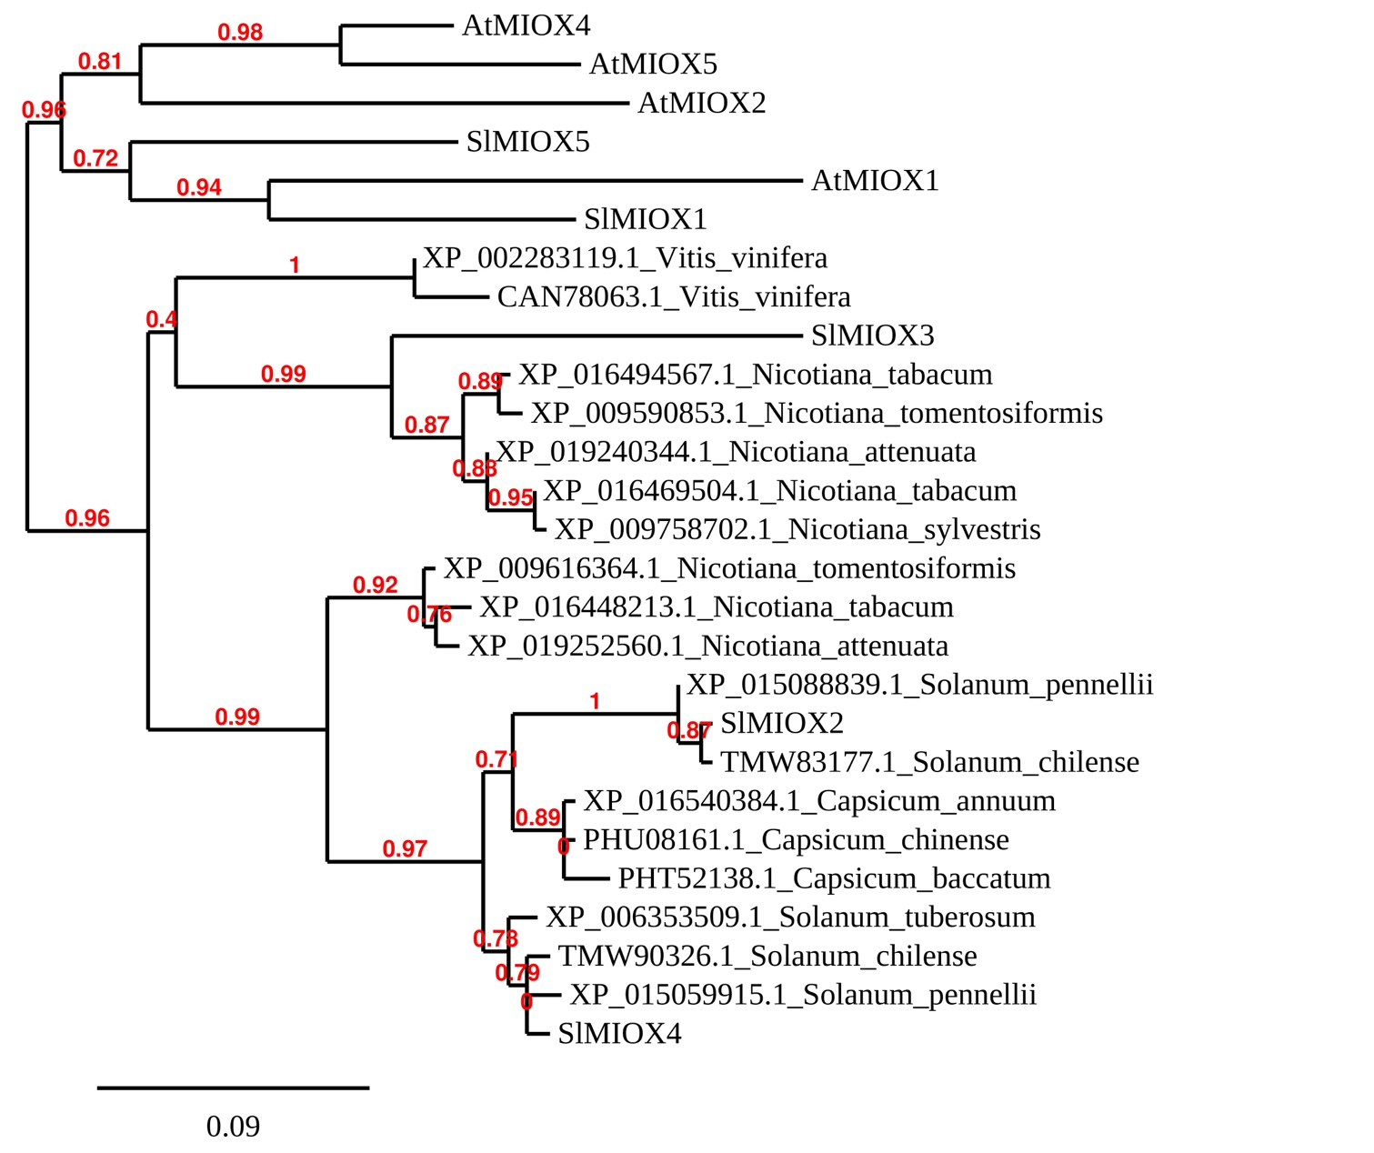
Figure S1

Figure S2

SlMIOX1 MRQVGPVLGRRKEECEIFDFSSVFSFTMTILI---------------------EQLPVEI
SlMIOX5 ------------------------------------------------------MVKMTI
SlMIOX3 ------------------------------------------------------MFLILL
SlMIOX2 MAIVQALFPSQYLCMNKTKNNTQIGSKRSIQVSCRSSNQEDLLSRRQTSYNHSDEFGLQV
SlMIOX4 ---------------------------MTILI---------------------EQPEFGS
.

SlMIOX1 QADETNIHAQNQKELVLGDGFAVPET-------------NAFGHNFRDY-TVESARQQGV
SlMIOX5 QLEGKKIQDQDQ--------FMVPQT-------------NAFGHDFRDYNNAQSERQKGV
SlMIOX3 ------IAELDNKKAISDGIFVVPGN-------------NAFGNSFRDY-NAEAERQKIV
SlMIOX2 EVEEKKVASFNGNEGVV---FEVSNI-------------NAFGQSFRDY-NAKSERQKSV
SlMIOX4 QVEEKKV-SFNANELILDGGFMVPKTLSSQDEIFEVPDINAFGQSFRDY-NVESERQKSV
: : * *. ****:.**** ..:: **: *

SlMIOX1 ENFYKINHFNQTYDYVSKMRVEYAKLDKAEMSIWECCELLNDVVDDSDPDLDEPQIQHLL
SlMIOX5 EKFYKTQHINQTYDFVKKMREDYIKLDKAKMSIWECCELLNDVVDDSDPDLDEPQIQHLL
SlMIOX3 RELYRQSHINQTYDFVKKMREEYGKMNKVEMSIWECCELLNEVVDDSDPDLDEPQIEHLL
SlMIOX2 EEFYRVQHINQTYDYVTKMRKEYGKLNKIEMSIWDCCELLNDVVDDSDPDLDEPQIEHLL
SlMIOX4 EEFYRVQHINQTYDYVKKMRKEYGKLNKIEMSIWDCCELLNDVVDDSDPDLDEPQIEHLL
::*. .*:*****:*.*** :* *::* :****:******:**************:***

SlMIOX1 QSAEAIRKDYPDEDWLHLTALIHDLGKVLLLPSFGELPQWAVVGDTFPVGCAFHDSIVHS
SlMIOX5 QSAEAIRKDYPNEDWLHLTALIHDLGKILVLPKFGGLPQWAVVGDTFPLGCAFDESNIHH
SlMIOX3 QTAEAIRKDYPNEDWLHLTGLIHGL----------------VEG---PSETTSDCLILQQ
SlMIOX2 QTAEAIRKDYPNEDWLHLTGLIHDLGKVLLHPSFGELPQWAVVGDTFPLGCAFDESIVHH
SlMIOX4 QTAEAIRKDYPNEDWLHLTGLIHDLGKVLLHPSFGGLPQWAVVGDTFPLGCAFDESIVHH
*:*********:*******.***.* * * * : ::

SlMIOX1 KYFKENPDYNNTAYKSKFGVYSEGCGLDKVLMSWGHDDYMYLVAKENGTTLPSAGLFIIR
SlMIOX5 KYFKENQDFNNPIYNTKNGIYNDSIGLENVMMSWGHDDYMYMVAKENGTTLPSAGLFIIR
SlMIOX3 --LKGNPDNNNPTYNTKYGVYSEGCGLNNVVMSWGHDDYMYLVAKANKTTLPSAALFIIR
SlMIOX2 KYFKENQDINNMIYNTKNGVYEEGCGLNKVVMSWGHDDYMYLVAKENGTTLPYAALFVIR
SlMIOX4 KYFKENPDINNNIYNTKNGVYEEGCGLDKVVMSWGHDDYMYLIAKENKTTLPSAALFVIR
:* * * ** *::* *:*.:. **::*:**********::** * **** *.**:**

SlMIOX1 YHSFYALHKSGAYKELMNEEDKENLKWLHIFNKYDLYSKSKVQVNVEEVKPYYMSLIEKY
SlMIOX5 YHSFYPLHKNGGYKHLMNDEDEENLKWLHVFNKYDLYSKSKVHVNVEEVKPYYMSLIEKY
SlMIOX3 YHSFYPLHKSGAYSHLMNEEDHENLKWLQIFSKYDLYSKSNVRIDVEKVKPYYMSLIEKY
SlMIOX2 YHSFYALHKSGAYKHLMNEEDKENIKWLNIFNKYDLYSKSSVRIDVENVKPYYLSLIQKY
SlMIOX4 YHSFYALHRSGAYTHLMNEEDKENMKWLNIFNKYDLYSKSKVRIDVEKVKPYYLSLIEKY
*****.**..*.*. ***:** **:***::*.********.*.::**:*****:***:**

SlMIOX1 FPAKLKW
SlMIOX5 FPAKLRW
SlMIOX3 FPSKLKW
SlMIOX2 FPKILRW
SlMIOX4 FPTKLRW
** *.*

